**Ralph N. Purcell, M.D.**

***Welcome***

Thank you for the opportunity to take care of you.

Welcome to our office. Please note that co-pays, coinsurance amounts due and all fees not covered by an insurance plan are due at the time of your office visit. We accept checks and cash. There are no payments required for the first three postoperative office visits, except when supplies are utilized or x-rays are taken.

Please do not discuss fees with the physician. Dr. Purcell will focus only on your medical needs. The office staff will answer all financial questions.

**HIPAA Acknowledgement**

I have been presented with a copy of the Centers Notice of Privacy Policies, detailing how my information may be used and disclosed as permitted under federal and state law. I understand the contents of the notice and I request the following restriction(s) concerning the use of my personal medical information. If you have no restrictions, please write the word “none.” Thank you.

____________________________________________________________________

____________________________________________________________________

My signature below permits a copy of this authorization to be used in place of the original and request payment of medical insurance benefits either to myself or to the party that accepts assignment. Regulations pertaining to medical assignment of benefits apply.

Legal Patient Name Printed: _____________________________________________

Signature: __________________________ Date: _______________________

If not signed by patient, please indicate relationship to patient: ______________

If the patient or representative refuses to sign, office staff will indicate below the attempt to obtain the signature:

( ) Patient refused to sign this acknowledgement.

Date: ____________ Employee Signature: ___________________

Printed Legal Name of Employee: ___________________________

Patient Name: _________________________________________________

Dr. Purcell will not share your contact information with third parties, except as set forth in the Privacy Policy. A copy of the privacy policy is available at your request.

Consent to Treat

By signing this form, I __________________, consent to evaluation and management of my orthopedic condition by Dr. Ralph Purcell.

By signing this form I acknowledge that Dr. Purcell and/or his representatives will file insurance claims for Medicare Services, Workers Compensation Services, all contracted insurance carriers and all out of network insurance carriers. I understand that any balance of my account is solely my responsibility. I authorize release of medical information for my insurance claims, and authorize payment of insurance benefits to Ralph N. Purcell, M.D.. I am responsible for all fees, legal and otherwise, incurred for collection purposes.

By signing this form I acknowledge that I have been provided the opportunity to receive a copy of and review the Privacy Notice Regarding Protected Healthcare Information (PHI).

Authorization to Release Information

By signing this form I authorize Ralph N. Purcell, M.D. to release and communicate healthcare information to the individuals noted below: (please cross this area out if you do not wish to release information to others)

Name of person(s):_______________________ Relationship: ________________ Phone: _____________

Name of person(s):_______________________ Relationship: ________________ Phone: _____________

Patient or Parent Signature: __________________________________

Date: ____________________________

Ralph N. Purcell, M.D.

Legal Name: _____________________________________________________________________________

Address: ________________________________________________________________________________

City: ______________________________ State: ________________ Zip:_________

E-mail: ________________________ Driver’s License Number: ____________________ State: ________

Telephone(s):

Home_____________ Work______________ Cell _____________

Date of Birth: ______________________ Age: _______ Social Security #_____________________

Place of Birth: _____________________ Height: _________ Weight: __________

⁭ Single ⁭ Married ⁭ Divorced ⁭ Partner ⁭ Widowed/Widower ⁭ Significant Other

Current Occupation: ______________________ Current Employer: _________________________________

Emergency Contact: ________________________ Telephone: _____________ Relationship: ____________

Referring Provider Name: ___________________________ Phone Number: __________________________

Primary Care Provider: _____________________________ Primary Care Number: _____________________

**FINANCIAL INFORMATION:** ( ) self pay ( ) Insurance ( ) Medicare ( ) Worker’s Compensation

( ) Attorney

**Primary Policy**

Name of Company: _____________________________________________

Policy Number: _____________________________ Identification Number: _______________________

Name of Primary Policy Holder: _______________________________ Relationship to Insured: ________

**Secondary Policy (if any)**

Name of Company: ______________________________________________

Policy Number: _____________________________ Identification Number: ________________________

Name of Primary Policy Holder: _______________________________ Relationship to Insured: ________

**Patient or Parent Signature: ________________________________ Date: _______________**

**Worker’s Compensation/Work Injury/ (if applicable)**

Workers Compensation Company (if applicable) ________________________________________________

Date of Injury: _______________________ Employer at Time: __________________________________

Adjuster/Claims Rep Name and Telephone Number: _____________________________________________

Claim Number, If Known: ______________________ Represented by Attorney? _____________________

**Attorney’s (if applicable)**

Law Firm:  **___________________________________________________________________**

Attorney’s Name: _________________________________________________________________________

Attorney’s Phone Number: ________________________ Attorney’s Fax Number: _____________________

Attorney’s Address: _______________________________________________________________________

Attorney’s Email: _________________________________________________________________________

Date of Injury: **________________________**

**Patient or Parent Signature: _____________________________________ Date: _____________**

**MEDICAL HISTORY FORM**

**Present Illness:**

What is the chief reason you are consulting with Dr. Purcell? ______________________________

_______________________________________________________________________________

_______________________________________________________________________________.

When did the problem first begin? _______________ Is it an on-the-job injury? ( )yes ( )no

Have you had treatment for this problem before today? ( )yes ( )no Have you had surgery for this problem in the past? ( )yes ( )no. If yes to either question, please explain below:

________________________________________________________________________________

________________________________________________________________________________

________________________________________________________________________________

History of Illnesses – please circle any of the following illnesses you have or have had:

Diabetes Heart Attack Stroke Unexplained Chest Pain High Blood Pressure

Hepatitis (type:____) HIV Lung Disease Seizures Asthma Rheumatoid Arthritis

List Others: _______________________________________________________________

Current Medications (include vitamins, diet pills, over the counter): _________________________

______________________________________________________________________________

______________________________________________________________________________

Medication Allergies: ( )none ( )yes – if yes, please list: ________________________________

______________________________________________________________________________

Bleeding Problems: Do you take anti-coagulants? ( )yes ( )no If yes, type: _________________

Do you take daily Aspirin or other NSAIDS? ( )yes ( )no If yes, type: ______________________

Have you or any of your close family members had problems with anesthesia? ( )yes ( ) no

If yes, please list issue: ______________________________________________________

Do you smoke or use tobacco products? ( )yes ( ) no If yes, type: ________________________

If yes, how much: ___________________ For many years? ______________________

Do you consume alcohol? ( )yes ( ) no If yes, how many drinks per day? __________________

**Patient Signature: ______________________________ Date: ________________________**

**COMPREHENSIVE MEDICAL QUESTIONNAIRE**

Please Indicate Yes or No to Each Condition

**Ear/Nose/Throat**

Hearing Loss ( ) yes ( )no

**Cardiology**

Chest Pain ( ) yes ( )no

Palpitations ( ) yes ( )no

Leg Swelling ( ) yes ( )no

High Blood Pressure ( ) yes ( )no

History of Heart Attack ( ) yes ( )no

Angina ( ) yes ( )no

Congestive Heart Failure ( ) yes ( )no

History of Heart Surgery ( ) yes ( )no

History of Angioplasty ( ) yes ( )no

History of Cardiac Cath ( ) yes ( )no

Pacemaker ( ) yes ( )no

AICD (Internal Defibrillator) ( ) yes ( )no

Heart Murmur ( ) yes ( )no

Rheumatic Heart Disease ( ) yes ( )no

**Gastroenterology**

Blood in Stools ( ) yes ( )no

Diarrhea Currently ( ) yes ( )no

Vomiting Currently ( ) yes ( )no

Constipation ( ) yes ( )no

Nausea ( ) yes ( )no

Difficulty Swallowing ( ) yes ( )no

Abdominal Pain ( ) yes ( )no

Change in Bowel Habits ( ) yes ( )no

Heartburn ( ) yes ( )no

**Dermatology**

Current Rashes ( ) yes ( )no

Current Hives ( ) yes ( )no

Diagnosis of Raynaud’s Disease ( ) yes ( )no

Alopecia (Hair Loss) ( ) yes ( )no

History of Skin Cancer ( ) yes ( )no

**Respiratory**

Shortness of Breath ( ) yes ( )no

Cough ( ) yes ( )no

Asthma ( ) yes ( )no

Sinus Issues ( ) yes ( )no

Ever had general anesthesia? ( ) yes ( )no

**Ophthalmology**

Do you have uncorrected vision loss? ( ) yes ( )no

Do you have Glaucoma? ( ) yes ( )no

**Patient Signature: __________________________________________ Date: ________________________**

**Allergies**

Do you have environmental allergies (dust, mites, etc) ( ) yes ( )no

If yes, what type? ________________________________________________________

**Endocrinology**

Fatigue ( ) yes ( )no

Excessive Sweating ( ) yes ( )no

Excessive Thirst ( ) yes ( )no

Excessive Urination ( ) yes ( )no

Unexplained weight loss ( ) yes ( )no

Cold Intolerance ( ) yes ( )no

Heat Intolerance ( ) yes ( )no

Diabetes ( ) yes ( )no

Insulin Dependent ( ) yes ( )no

Oral Medication Dependent ( ) yes ( )no

Diet Controlled ( ) yes ( )no

Thyroid Disease ( ) yes ( )no

**Neurology**

Migraine Headaches ( ) yes ( )no

Other Headaches ( ) yes ( )no

Numbness/Tingling Hands ( ) yes ( )no

Numbness/Tingling Feet ( ) yes ( )no

History of Seizures ( ) yes ( )no

Memory Loss ( ) yes ( )no

Dizziness ( ) yes ( )no

Weakness ( ) yes ( )no

Restless Leg Symptoms ( ) yes ( )no

Tremors ( ) yes ( )no

Difficulty with gait/walking ( ) yes ( )no

Peripheral neuropathy ( ) yes ( )no

History of Stroke ( ) yes ( )no

History of Chemotherapy ( ) yes ( )no

History of Radiation Therapy ( ) yes ( )no

Heavy Metal Exposure ( ) yes ( )no

**Other Conditions**

Anemia ( ) yes ( )no

Osteoarthritis ( ) yes ( )no

Cancer (type _________________) ( ) yes ( )no

Blood Transfusion in Past ( ) yes ( )no

Hepatitis ( ) yes ( )no

Kidney Disease ( ) yes ( )no

MRSA ( ) yes ( )no

Tuberculosis ( ) yes ( )no

Sleep Apnea ( ) yes ( )no

**Patient Signature: _______________________________________________ Date: ___________________**

**Hematology/Lymph**

Swollen Glands ( ) yes ( )no

Fatigue ( ) yes ( )no

Loss of Appetite ( ) yes ( )no

Night Sweats ( ) yes ( )no

Fever ( ) yes ( )no

**Urology**

Frequent Urination ( ) yes ( )no

Burning on Urination ( ) yes ( )no

Urinary Incontinence ( ) yes ( )no

**Family History**

Do any of your Family Members have any of the following conditions?

( ) Breast Cancer ( ) Diabetes ( ) Heart Disease

( ) Stroke ( ) Kidney Disease ( ) Other Cancer

( ) Depression ( ) High Blood Pressure ( ) Melanoma

**Any additional information related to your health that is not included in questions above:**

________________________________________________________________________________

________________________________________________________________________________

________________________________________________________________________________

________________________________________________________________________________

**Patient Signature: _____________________________________________ Date: ____________________**

**PAIN MEASUREMENT**

Please Shade In Areas of Pain Below

More Detailed Hand Diagram on Following Two Pages

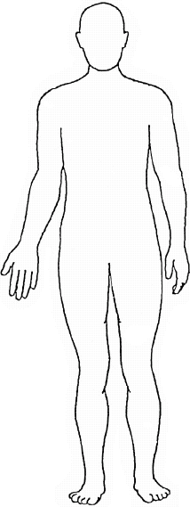 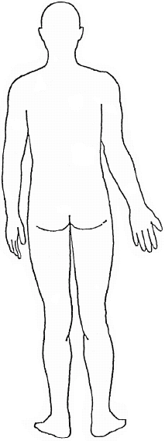

**Numerical Rating Scale: 0 equals no pain, 10 equals the worst imaginable pain (Circle One)**

|  |  |  |  |  |  |  |  |  |  |  |  |
| --- | --- | --- | --- | --- | --- | --- | --- | --- | --- | --- | --- |
| **Overall Pain Now** | **0** | **1** | **2** | **3** | **4** | **5** | **6** | **7** | **8** | **9** | **10** |
| **Average Pain Over Past Week** | **0** | **1** | **2** | **3** | **4** | **5** | **6** | **7** | **8** | **9** | **10** |
| **Worst Pain Over Past Week** | **0** | **1** | **2** | **3** | **4** | **5** | **6** | **7** | **8** | **9** | **10** |
| **Least Pain Over Past Week** | **0** | **1** | **2** | **3** | **4** | **5** | **6** | **7** | **8** | **9** | **10** |
| **Acceptable Level of Pain** | **0** | **1** | **2** | **3** | **4** | **5** | **6** | **7** | **8** | **9** | **10** |
| **I would be happy with my treatment/could do**  **the things I want/return to work, etc. if I had**  **a pain level of:** | **0** | **1** | **2** | **3** | **4** | **5** | **6** | **7** | **8** | **9** | **10** |
|  |  |  |  |  |  |  |  |  |  |  |  |
| **What is your current level of pain relief with**  **any current medications or treatments?**  **0 equals no relief, 10 equals complete relief** | **0** | **1** | **2** | **3** | **4** | **5** | **6** | **7** | **8** | **9** | **10** |

**What specific medications or treatments are you currently using to help manage your pain?**

**___________________________________________________________________________________**

**___________________________________________________________________________________**

**Patient Signature: ____________________________________________Date: __________________**

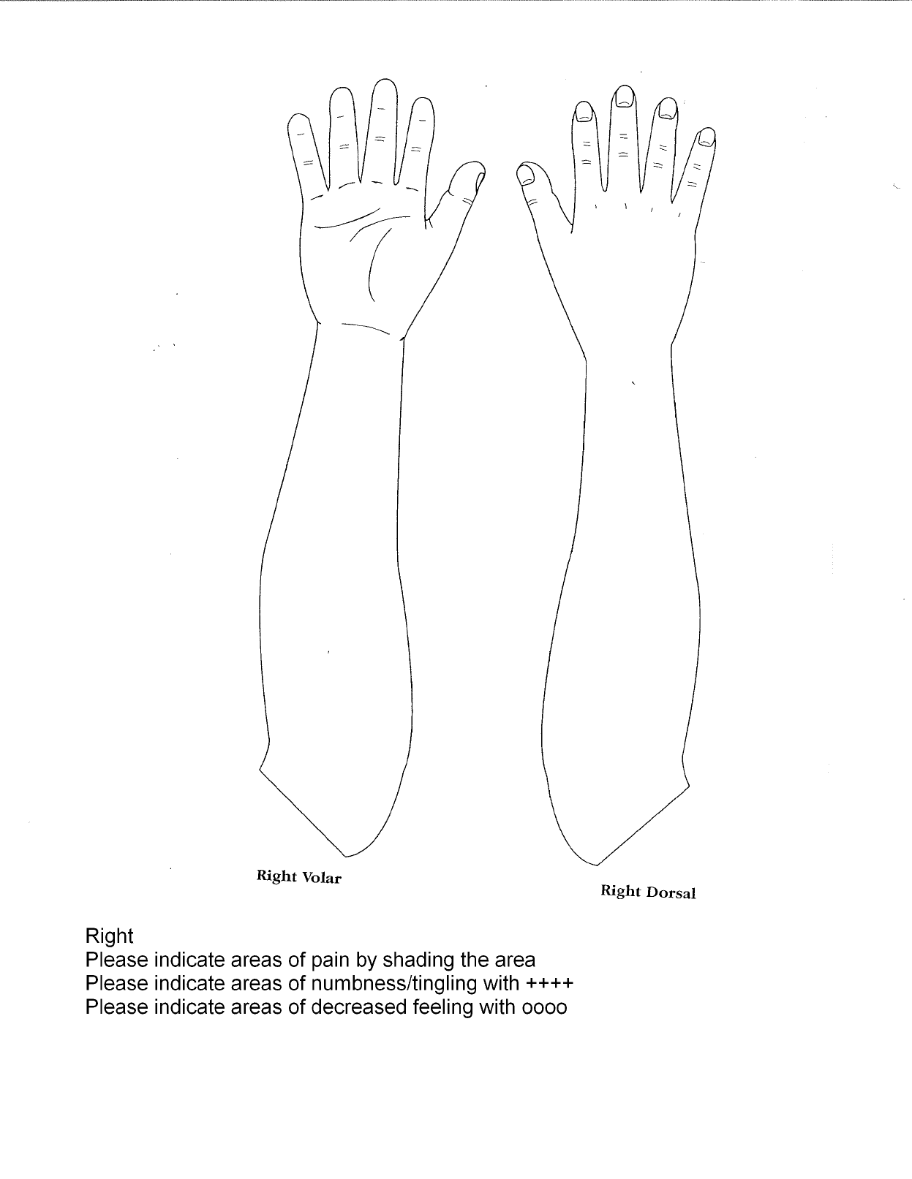

**Patient Signature: _______________________________________________ Date: __________________**

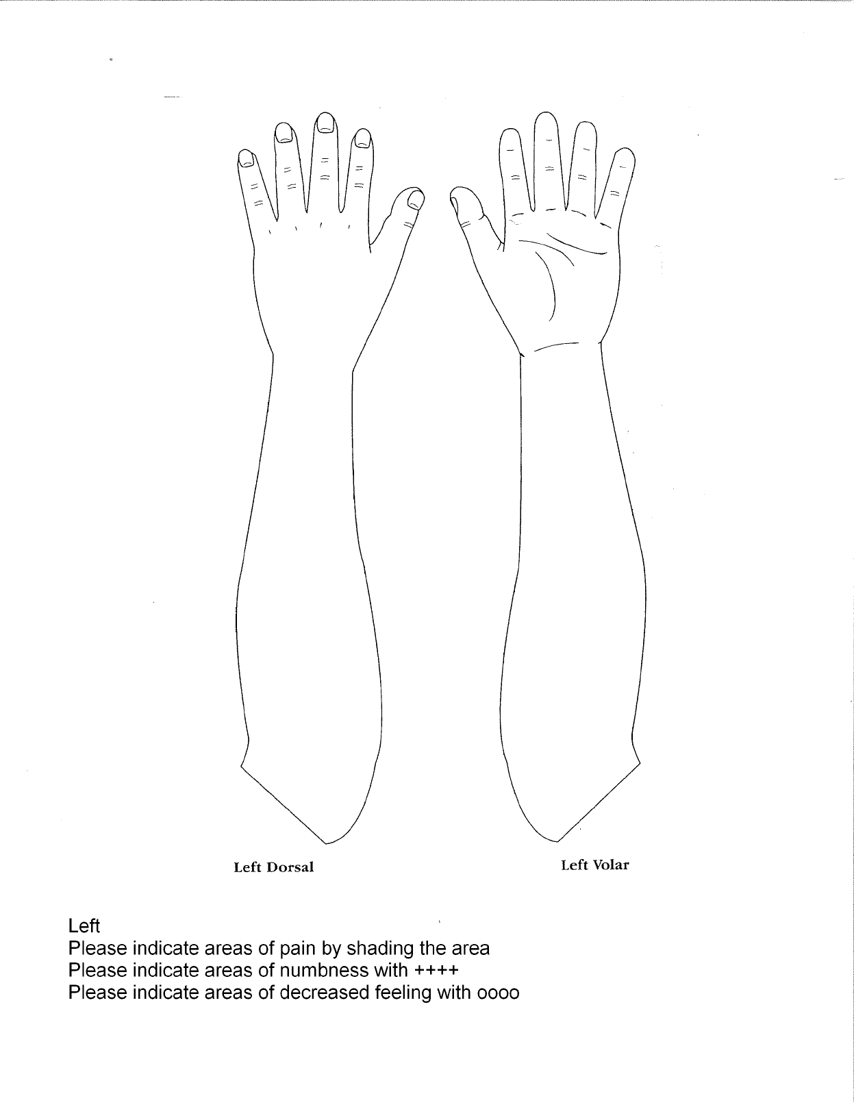

**Patient Signature: _______________________________________________ Date: ___________________**

**INSURANCE ACKNOWLEDGEMENT AND ENDORSEMENTS**

PATIENT LEGAL NAME: ___________________________________________________________________

RECORDS RELEASE

I hereby authorize Ralph N. Purcell, M.D. to furnish any medical records and/or other necessary information needed to process an insurance claim.

____________________________ ______________________ __________

Signature of Responsible Party Printed Name Date

ASSIGNMENT OF BENEFITS

I, the undersigned, am the financially responsible party for the patient named above and agree to pay, in full, Ralph N. Purcell, M.D. for services rendered. I accept Dr. Purcell’s fees as reasonable and customary.

I, irrevocably, assign to Ralph N. Purcell, M.D. all payments from insurance company(ies) for medical services rendered and accept responsibility for paying any balance owed after the insurance has paid.

In order to process an insurance claim, there must be complete patient information and insurance information on file.

All patients whose insurance provider pays the patient directly, rather than Ralph N. Purcell, M.D., hereby agree to assign all benefit proceeds the patient/guarantor receives from the insurance company to Ralph N. Purcell, M.D. My signature below signifies my agreement to immediately endorse all checks received from my insurance company and bring them into the physician’s office.

_____________________________ ______________________ ___________

Signature of Responsible Party Printed Name Date

**NON-WORKMAN’S COMPENSATION DECLARATION**

Dr. Purcell is unable to determine whether or not the symptoms you are suffering are work related.

By signing below you declare that you do not have a compensable work injury covered under a workman’s compensation claim at this time.

By signing below you declare that you will notify this office if you file a workers compensation claim related to the condition you are seeing Dr. Purcell for. By signing below you also indicate that should you file a claim, and should the claim be denied by the workers compensation carrier, you will be directly responsible for all balances in full. If private or group health insurance is available, this office must receive a copy of the information in order to process the regular health insurance should your claim be denied. This is not a guarantee that we accept your private or group insurance plan.

_____________________________ ______________________ ___________

Signature of Responsible Party Printed Name Date